Projet POO 2025

Document Technique

Presenting different diagrams for our app

Table of Contents

1. Class diagram  2

2. Use Case Diagram  3

3. Sequence Diagrams  4

**List of figures**

Figure 1: Class  2 diagram

Figure 2: Use case diagram  3

Figure 3: Authentication Sequence Diagram  4

Figure 4: Sequence diagram of adding a book  5

Figure 5: Sequence diagram of a loan  5

Figure 6: Sequence diagram of a loan return  5

# 1. Class diagram

The class diagram below models a library management system composed of six main classes. The User class represents users, who can make multiple loans ( Loan ), save books ( Book ), and receive notifications ( Notification ). Each loan is linked to a single user and a single book, and contains information such as loan and return dates, as well as status. Books are described by attributes such as title, author, number of copies, and belong to a single category ( Category ). A category groups several books, allowing thematic organization. The notification system allows sending dated messages to users, facilitating automated communication (e.g., reminders). All of these relationships ensure consistent management of loans, resources, and user interactions within the library.

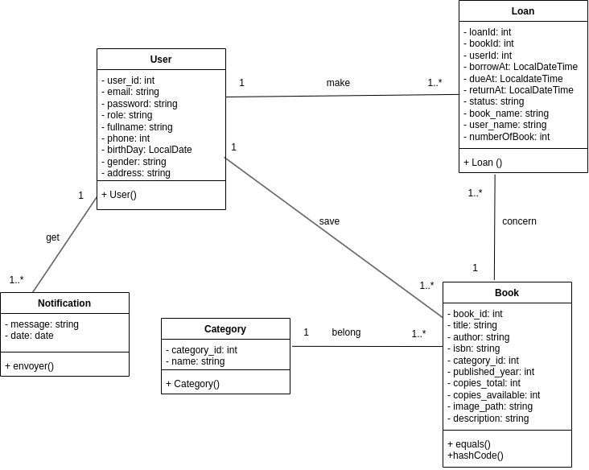

Figure 1:diagramme de classe

# 2. Use case diagram

The use case diagram below models the possible interactions between an administrator ( Admin ) and the library management system. The administrator can perform various operations such as viewing the lists of books, borrowings, and users, as well as adding books. Use cases like update_book_data , delete_book , or cancel_loan are optional extensions triggered from the main cases like check_books_list or check_loan_list . Some operations, like validate_loan , validate_loan_return , or delete_user , require prior authentication, represented by the To authenticate use case included in several others. This diagram highlights the various system administration functionalities and the logical relationships between them via the << include >> (mandatory) and << extend >> (optional) relationships.

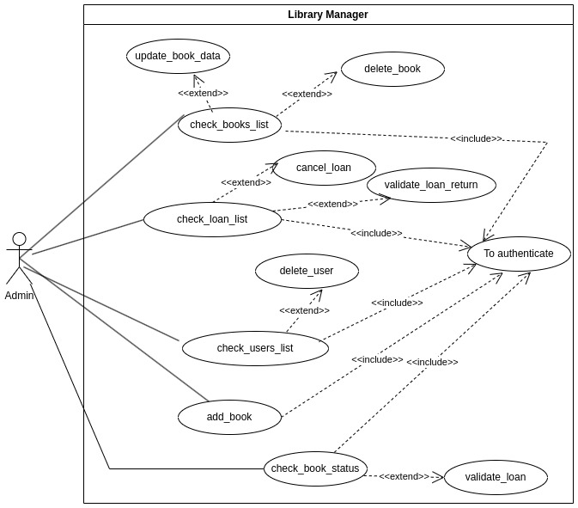

Figure 2:Diagramme de cas d'utilisation

# 3. Sequence Diagrams

This sequence diagram illustrates the authentication process of an administrator in the library management system. The interaction begins when the admin enters his username and password (step 1). The system then sends this information to the database (DB) for verification (steps 2 and 3). Once the information is verified, the database returns a response to the system (step 4). Depending on the response received, two scenarios are possible: if the information is valid ( Response == True ), the system creates a user session (step 5) and redirects the administrator to the dashboard (step 6). Otherwise, an error message is sent to the user (step 7). This diagram highlights the exchanges between actors and components to ensure secure and conditional authentication.

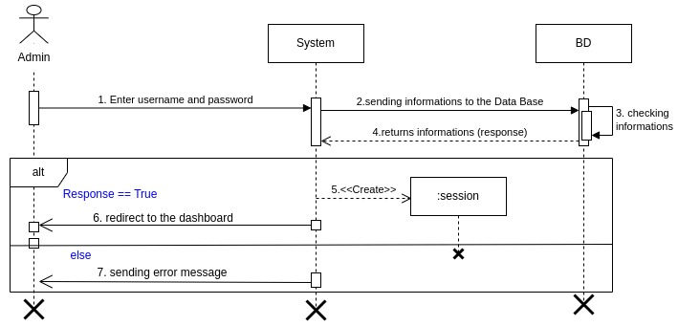

Figure 3:diagramme de séquence d'authentification

The sequence diagram below illustrates the process of an administrator adding a book to the system. It highlights the key interactions between the administrator, the system, and the book object, detailing the essential steps: interface request, information entry, book creation, and registration confirmation. This visual representation helps to better understand the process flow and facilitates its analysis and implementation.

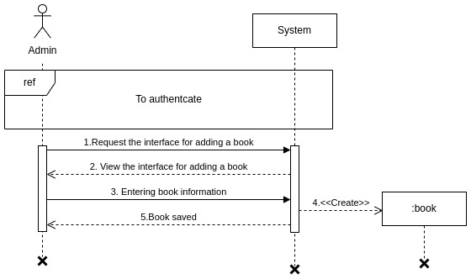

Figure 4: diagramme de séquence d'ajout d'un livre

This flowchart illustrates the process by which an administrator interacts with the system to manage book loans. It details the key steps: requesting a book list, viewing the list, filling out a form, and creating the loan. It also highlights an authentication point, essential for securing the transaction. This visualization helps clarify interactions and better understand the process flow.

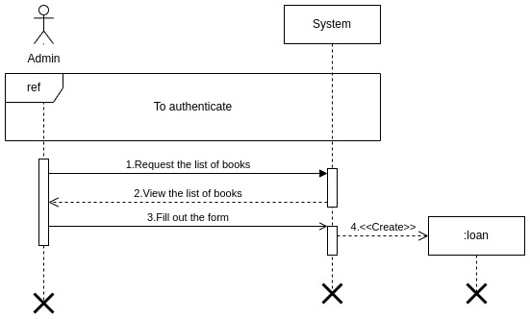

Figure 5: diagramme de séquence d'un emprunt

The sequence diagram below shows the steps for validating a loan return. This involves authentication if it is not in the software, then the list of books where it selects the book in question and cancels the loan, which allows it to be considered available.

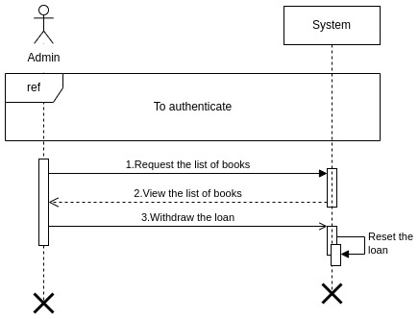

Figure 6: diagramme de séquence d'un retour d'emprunt